**IPv4 CLASS DISTRIBUTION**

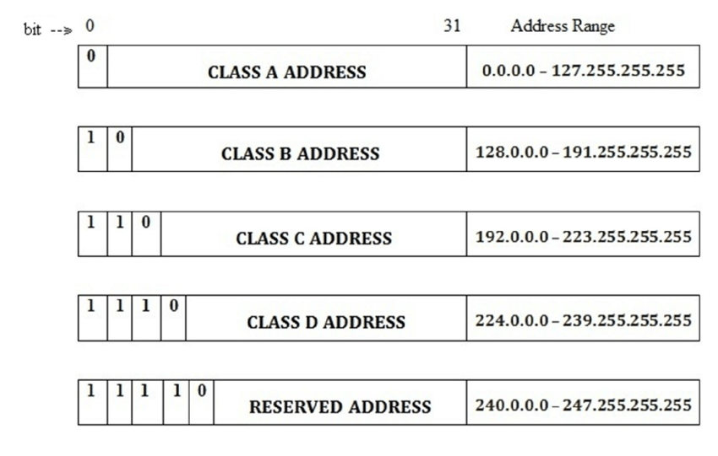

**Class A Subnets**

**Class B Subnets**

**Class C Subnets**

